Documentation for dynamic algorithm
Pseudocode:
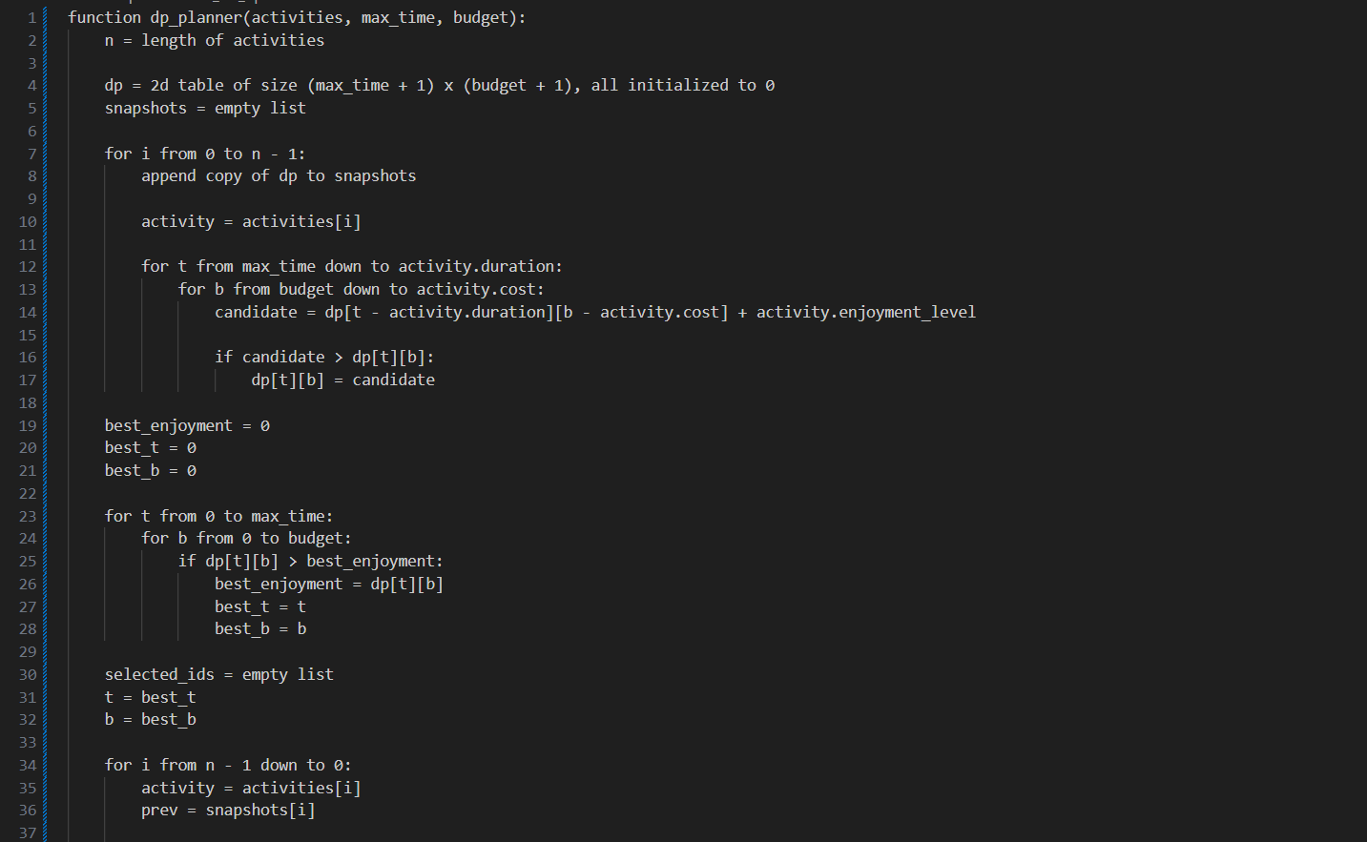
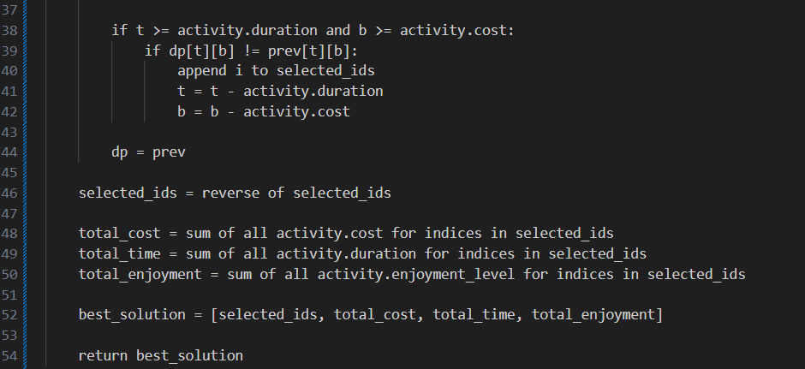
Logic and approach
The algorithm creates a table where each row represents a possible amount of time you could spend (from 0 up to max_time) and each column represents a possible amount of money you could spend (from 0 up to budget). At the start, the table is full of zeros because no activities have been considered yet.
For each activity, the algorithm checks if the activity improves the enjoyment for any time and budget combination. The algorithm performs this check by looking at the table backwards (so it doesn’t accidentally reuse the same activity twice). For each cell (time,budget), algorithm checks whether you could fit this activity into that time and budget. If yes, it calculates what the enjoyment would be if you included it and if that enjoyment is better than what’s currently in the bale, it updates the cell.
Before processing each activity, the algorithm takes a snapshot of the table. This is done because later, when the algorithm wants to reconstruct which activities were chosen, it needs to know whether adding activity “i” changed the table or not. These snapshots let the algorithm trace backwards and figure out exactly which activities contributed to the final best enjoyment.
Once all activities have been processed, the table contains the best enjoyment values for every possible time and budget combination. The algorithm scans the whole table to find the cell with the highest enjoyment. That cell tells you: how much time was used, how much money was used and what the maximum enjoyment is.
The algorithm works backwards to figure out which activities were chosen and this is were the snapshots are used. Starting from the best cell, the algorithm goes backwards through the activities: it compares the current table with the snapshot from before the activity was added, If the value in the cell changed that means the activity was included, if the vale stayed the same the activity was not included. Each time it finds and included activity, it subtracts the activity’s time and cost and continues tracing back. By the end, the algorithm has reconstructed the exact set of activities that produced the optimal enjoyment.
Time complexity
The algorithm fills in a 2D table where: one dimension is all possible time values (0 max_time), the other is all possible budget values (0 budget). For each activity, it scans through the entire table (backwards) and updates cells where the activity fits. This means that the work done grows with: the number of activities, multiplied by all possible time values, multiplied by all possible budget values. This gives this dynamic algorithm a polynomial time complexity.
Space complexity
The algorithm stores a large table with size (max_time + 1) * ( budget + 1). This table requires a lot of memory to store but the algorithm also stores a snapshot of the entire table before each activity is processed. So if there are n activities then there are n copies of the table. This means the memory grows with n * max_time * budget. This gives the algorithm a polynomial space complexity.

